Compliance Validator System Architecture Document
This document describes the refined, production-grade architecture of the Agentic AI Compliance Validator system. The architecture is designed to process complex financial invoices, apply Indian GST and TDS regulations, handle ambiguity using controlled reasoning, and generate auditable, human-trustworthy compliance outcomes.

1. Architectural Principles
The system follows a rule-first, agentic design philosophy. Deterministic compliance rules form the foundation of decision-making, while agentic reasoning is applied selectively for ambiguity. Key principles include:
- Separation of concerns across specialized agents
- Explainability and auditability of every decision
- Controlled autonomy with human-in-the-loop escalation
- Deterministic validation with optional LLM-assisted reasoning
- Extensibility through standardized tool interfaces (MCP)

2. High-Level System Flow
The system operates as a sequential, agent-driven pipeline. Invoices flow through specialized agents that progressively enrich, validate, reason, and report compliance outcomes.
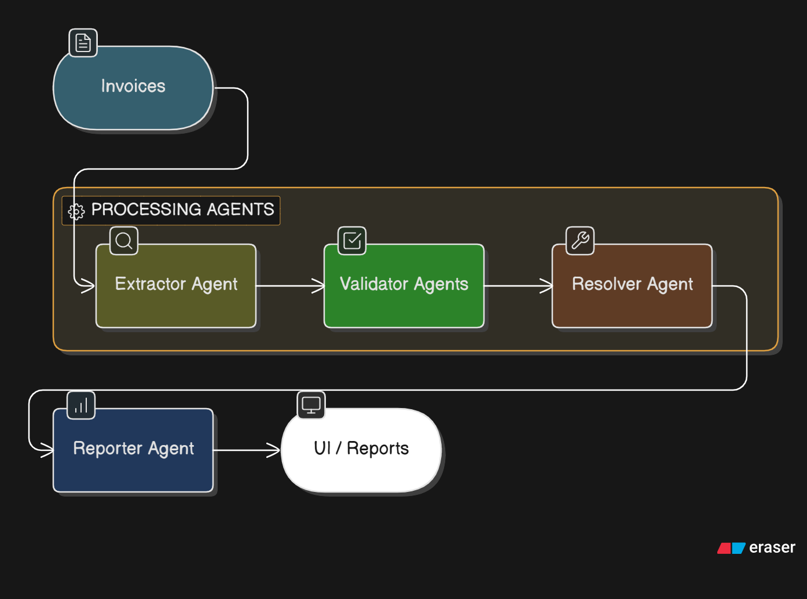

3. Codebase structure

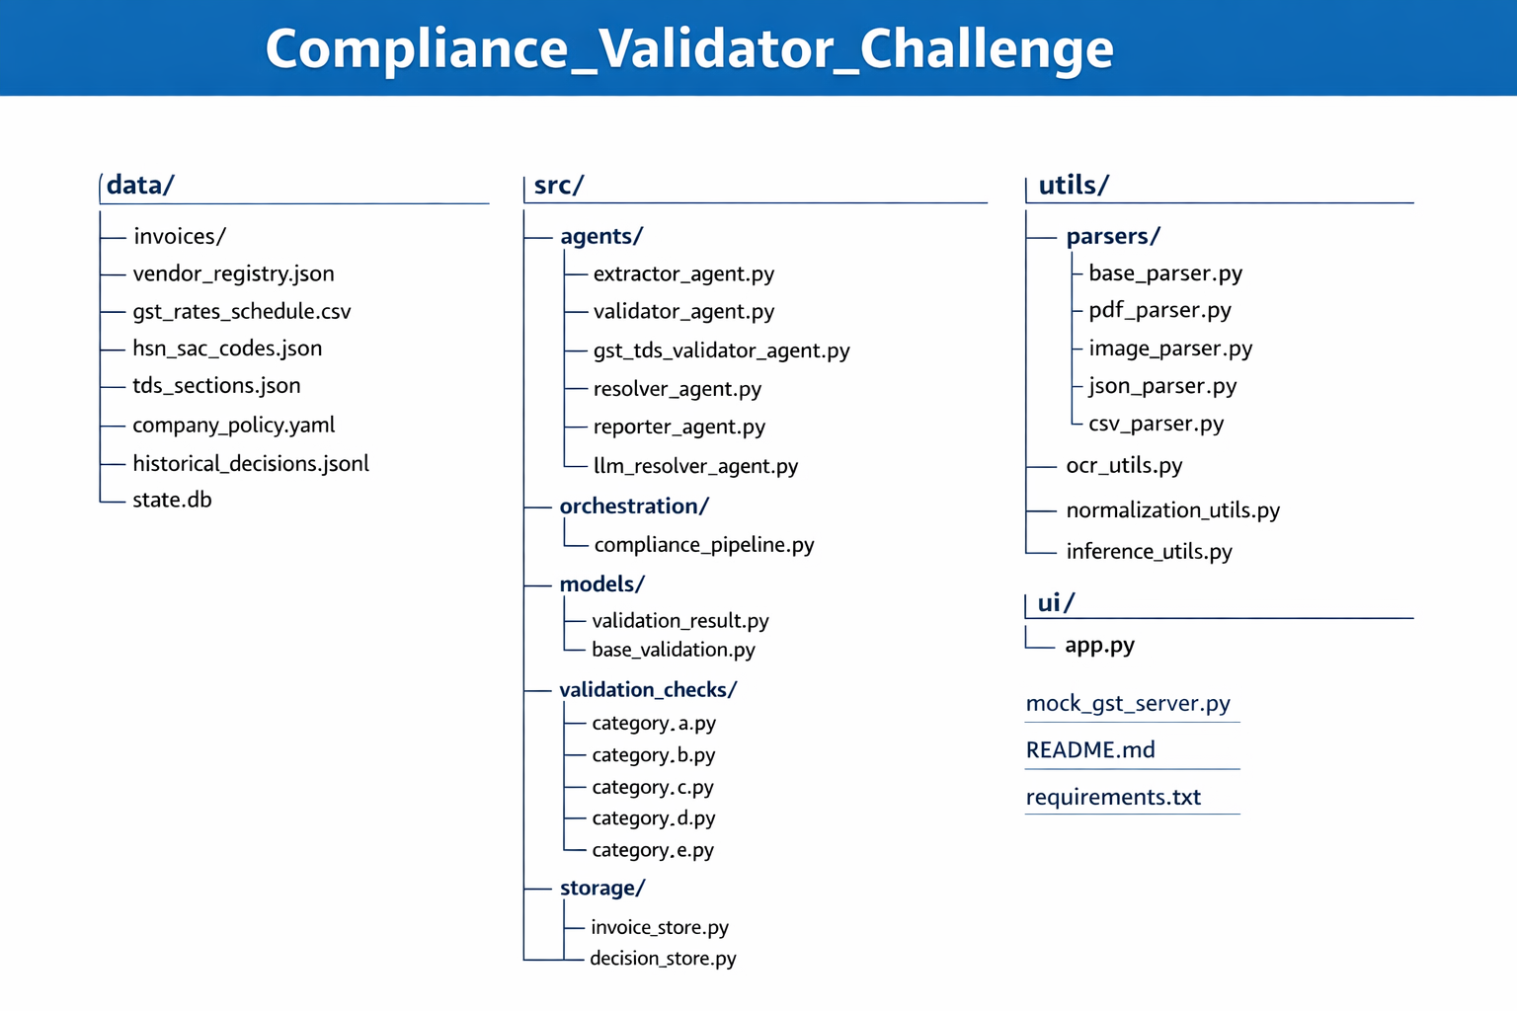

4. Agent Responsibilities

4.1 Extractor Agent
The Extractor Agent ingests invoices in PDF, image, JSON, and CSV formats. It performs OCR for scanned documents, normalizes extracted fields, corrects common OCR errors, infers missing attributes using reference data (vendor registry, historical invoices), and records processing metadata for observability.

4.2 Validator Agents
Validator Agents execute the 58-point compliance framework across five categories:
- Document Authenticity
- GST Compliance
- Arithmetic & Calculations
- TDS Compliance
- Policy & Business Rules
Each validation check emits structured evidence and confidence impact but does not make final approval decisions. This ensures determinism, traceability, and regulatory alignment.

4.3 Resolver Agent
The Resolver Agent handles ambiguous or conflicting regulatory scenarios. It evaluates multiple interpretations, incorporates historical context, applies confidence thresholds, and determines whether escalation is required. When enabled, it uses a local LLM (Ollama) for explainable reasoning without overriding deterministic rule outcomes.

4.4 Reporter Agent
The Reporter Agent consolidates validation evidence and resolution outcomes into actionable compliance reports. Reports are human-readable, tabular, downloadable (CSV/JSON/PDF), and audit-ready. Each report includes reasons for failure, confidence scores, escalation flags, and recommended corrective actions.

5. Tooling & Infrastructure
- GST Portal Mock API for regulatory verification
- MCP (Model Context Protocol) as a standardized agent-to-tool interface
- SQLite for stateful validation, duplicate detection, and historical tracking
- Gradio UI for interactive review and reporting
- Local LLM (Ollama – llama3) for controlled reasoning in edge cases

Conclusion
The Compliance Validator is a rule-first, agentic AI system that balances regulatory correctness with explainability and human oversight. MCP ensures consistent tool invocation and extensibility, while LLM reasoning is applied selectively to improve judgment without compromising trust or auditability.

